Gemstone Detector

# Submitted By

Ashfaq Ahmad 19PWCSE1795

Mansoor Hussain 19PWCSE1858

Amir suleman 19PWCSE1805

**Supervised by**

Engr. Madiha Mushtaq



2022-23

Department of Computer Systems Engineering University of Engineering & Technology, Peshawar

**UNIVERSITY OF ENGINEERING AND TECHNOLOGY, PESHAWAR, PAKISTAN**

B.Sc PROJECT PROPOSAL

|  |  |  |  |
| --- | --- | --- | --- |
| Proposal Title |  | | |
| Department | Computer Systems Engineering | | |
| Registration No. | Student Name | Email | Contact No. |
| 19PWCSE1795 | Ashfaq Ahmad | [19pwcse1795@uetpeshawar.edu.pk](mailto:19pwcse1795@uetpeshawar.edu.pk) | 03449024783 |
| 19PWCSE1858 | Mansoor Hussain | [19pwcse1858@uetpeshawar.edu.pk](mailto:19pwcse1858@uetpeshawar.edu.pk) | 03408443655 |
| 19PWCSE1805 | Amir Suleman | [19pwcse1805@uetpeshawar.edu.pk](mailto:19pwcse1805@uetpeshawar.edu.pk) | 03478663296 |
| Research  Supervisor | Engr. Madiha Mushtaq | | |

# Mapping of the Project with Computer Systems Engineering Subjects

|  |  |  |  |
| --- | --- | --- | --- |
| **S. No.** | **Course Code** | **Course Name** | **Possible linkage with the project (Justify)** |
| **1.** | **CSE-208** | **OOP** | In OOP we have studied class and object concept which we is used in our project. |
| **2.** | **CSE-403** | **DBMS** | DBMS is used in backend of our project for data storing and manipulation. |
| **3.** | **CSE-210** | **Data structure and algorithm** | ML is used in our project which links DSA. |
| **4.** | **CSE-304** | **Computer Programming** | Different programming languages are used in our project. |
| **5.** | **CSE-209** | **Probability** | The data will be collected through probability. |

# Introduction

A gemstone is a piece of mineral crystal in cut and polished form which is used to make jewelry or other adornments.  In earlier times there were no such things as synthetic gemstones but today they are quite common. Gemstones are an important commodity in today's marketplace. Gemstones are diverse in their beauty and many gems are available in a stunning variety of colors. Gemstones have attracted humankind since ancient times, and have long been used for jewelry. Of the more than 2,000 identified natural minerals, fewer than 100 are used as gemstones and only 16 have achieved importance.

Our FYP is about these gemstones which will detect the type of stone. Simply we will take or upload a picture of stone, and it will identify it just in few seconds.

We are making this stone detector for geologists and geology students that need help in the day to day identification of minerals, but it may also be interesting for normal people when it comes to learn more about mineralogy and how minerals are identified, and also the gemstone identifier uses different attributes to help you identify minerals.

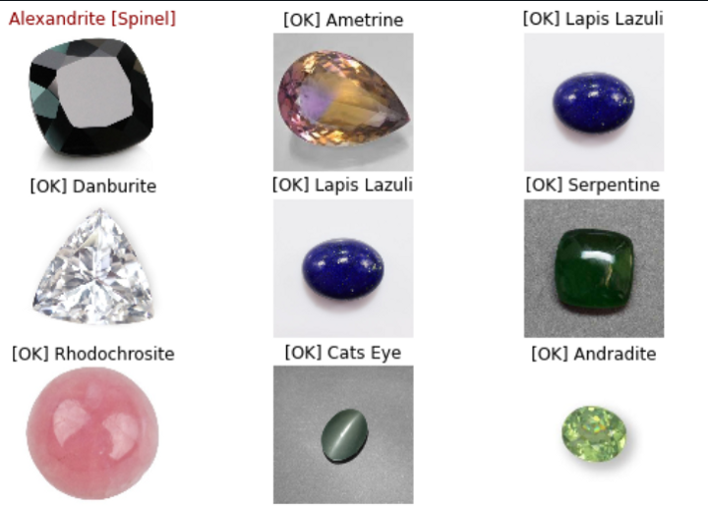

# Problem Statement:

# As we see now a day Gemstone has become a big business in Pakistan as well as in the whole world but a lot of people get deceived while buying it, because due to advanced technology people can’t detect the difference between original and duplicated stuffs.

# So our FYP’s Problem statement is “How to detect the Gemstone?”

# Methodology:

# First of all we will make planning for our project that from where we have to take a start, which tools are required in our projects, which stuffs are required for our project and which programming languages we have needs to learn. Next we will design UI for our Project by using flutter. After UI design we will train our application for detecting stone by any algorithm of Deep learning. Finally we will test our product by taking picture using camera or import picture from internal storage of cell phone.

**GANTT CHART:**

|  |  |  |  |  |  |  |
| --- | --- | --- | --- | --- | --- | --- |
| Work/Schedule Plan | **October**  **2022** | **November**  **2022** | **December**  **2022** | **January 2023** | **February**  **2023** | **March**  **2023** |
| Planning |  |  |  |  |  |  |
| UI Design |  |  |  |  |  |  |
| Create backend |  |  |  |  |  |  |
| Test |  |  |  |  |  |  |
| Final APP |  |  |  |  |  |  |

# Equipment/ Tools Usage:

* **IDE**
* **Machine learning**
* **Stones pictures**
* **Flutter**
* **Python**
* **Firebase**

**References:**

1. <https://medium.com/ai-techsystems/gemstone-classification-using-deep-learning-46ea270a4c03>
2. <https://nanonets.com/blog/machine-learning-image-processing/>
3. https://docs.flutter.dev/